Shoulder joint
- = glenohumeral joint
As a consequence of its flexibility, shoulder joint is unstable – prone for dislocation

- Most mobile joint
Articulating surfaces:
- glenoid cavity of scapula with head of humerus
- glenoid labrum deepens the cavity of cavity
Orientation of the joint:
- Head of humerus is oriented at 45⁰ from the long axis of the shaft and retroverted 30⁰.
- The shallow shaped glenoid cavity is retroverted and inferiorly angulated 5⁰ from the long axis of scapula
Type of joint:
- ball and socket synovial joint
Capsule of joint
Encloses tendon of long head of biceps.
Knee joint with tendon of popliteus is the only other intracapsular tendon

- Medially – to margins of glenoid cavity
- Laterally – to anatomical neck 1.5 cm on surgical neck
- Inferior attachment to humerus extends
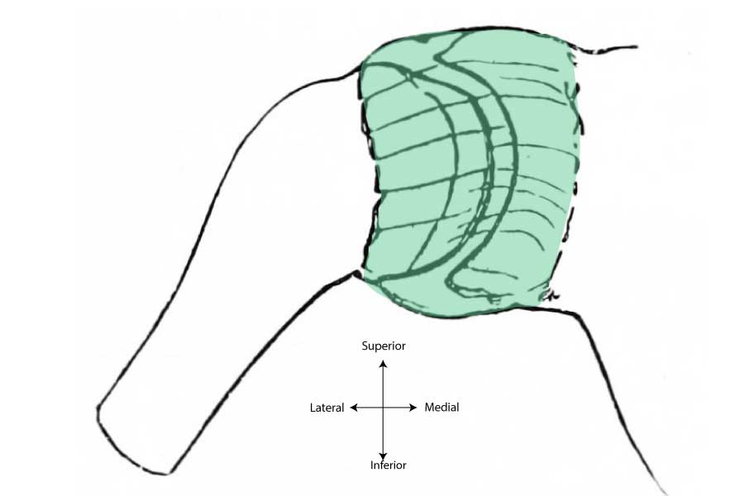
Synovial membrane
Portion of epiphyseal line of proximal humerus is intracapsular – septic arthritis of the shoulder joint may occur following metaphyseal osteomyelitis

Lines the inner aspect of joint capsule. Projects along the tendon of long head of biceps. Communicates with few bursae.
Ligaments
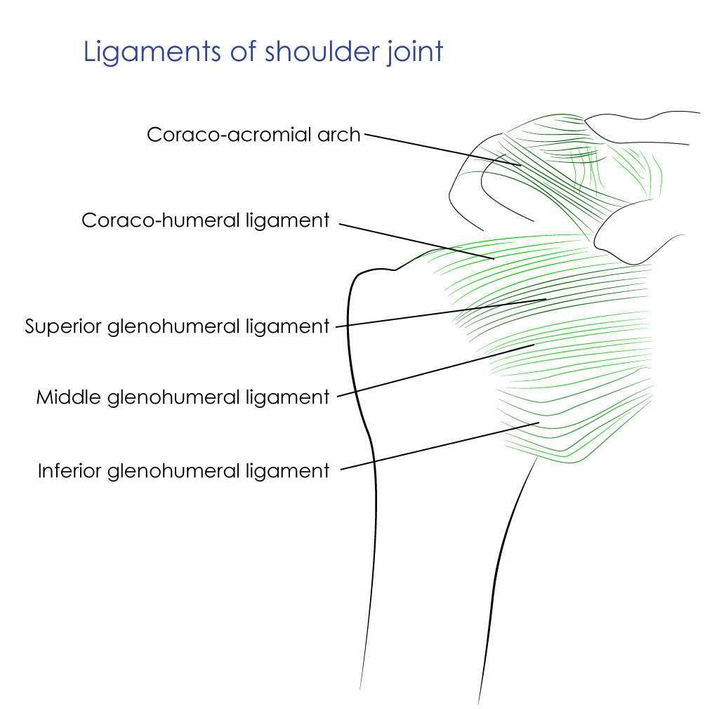
- Glenohumeral ligaments
  - Superior
  - Middle
  - Inferior
  - Gap between superior and middle glenohumeral ligaments is of noted significance in anterior dislocation of shoulder

- Coracohumeral ligament
  - From base of coracoid process to anterior aspect of greater tubercle of humerus
- Transverse humeral ligament – bridges the bicipital groove. Tendon of long head of biceps brachi passes beneath this ligament
- Coracoclavicular - accessory ligament
- Coracoacromial arch - an osseoligamentous arch around the head of humerus; subarachnoid bursa located superior to this arch
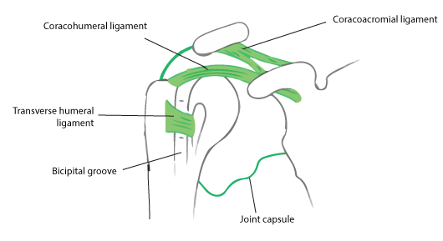
Bursae related to shoulder joint
- Subscapular bursa: lies between the tendon of subscapulris and neck of scapula
- Subacromial (subdeltoid) bursa: between coracoaromial ligament and acromian process above; and supraspinatus below
- Infraspinatus bursa: between tendon of infraspinatus and joint capsule
Relations of shoulder joint
- Superiorly: coracoacromial arch, subacromial bursa, supraspinatus and deltoid
- Inferiorly: long head of triceps, axillary nerve and posterior circumflex humeral vessels
- Anteriorly: subscapularis, subacromial bursa, coracobrachialis, short head of biceps and deltoid
- Posteriorly: infrapinatus, teres minor and deltoid

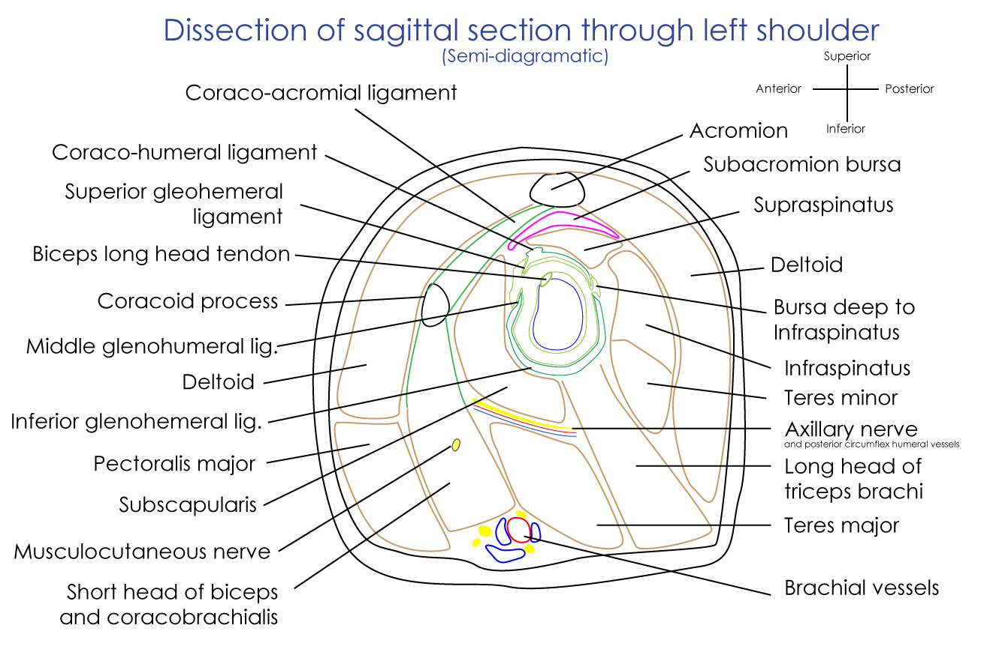

Nerve supply: axillary nerve, suprascapular nerve and musuclocutaneous nerve
Stability of shoulder joint
- Rotator cuff muscles
- Coracoacromial arch – forms secondary socket for glenohumeral joint
- Long head of biceps
- Glenoid labrum – deepens the shallow of glenoid cavity

Rotator cuff muscles
Formed from tendons of supraspinatus, infraspinatus, teres minor and subscapularis
Tendons of these four muscles fuse with underlying capsule
Primary function of rotator cuff is to hold the large head of humerus with a shallow glenoid cavity.
It allows fine adjustments of head of humerus within the glenoid cavity
Muscle | Origin | Insertion | Nerve supply | Action
Supraspinatus | Supraspinous fossa | Greater tubercle of humerus in order of  S  I  T | Suprascapular nerve (C5, 6) | Initiates abduction
Infraspinatus | Infraspinous fossa | Greater tubercle of humerus in order of  S  I  T | Suprascapular nerve (C5, 6) | Lateral rotator of arm
Teres minor | Upper part of lateral border of scapula | Greater tubercle of humerus in order of  S  I  T | Axillary nerve (C5, 6) | Lateral rotator of arm
Subscapularis | Subscapular fossa | Lesser tubercle of humerus | Upper and lower subscapular nerves (C5, 6, 7) | Adduction of arm

Movements
- Glenoid cavity is directed anterolaterally and head of humerus is directed posteromedially.
- Therefore, the plane of glenohumeral abduction and adduction is not in coronal plane but inclined 45⁰ to the sagittal plane
Movement | Axis | Range | Description | Muscle
Flexion | Sagittal plane along frontal axis | 90⁰ | Arm moves forwards and medially | Pectoralis major  Deltoid – anterior fibres
Extension | Sagittal plane along frontal axis | 45⁰ | Arm moves backwards and laterally | Deltoid – posterior fibres
Abduction | 45⁰ obliquely to coronal plane | 180⁰ | Arm moves anterolaterally away from trunk | Deltoid
Adduction | 45⁰ obliquely to coronal plane | 45⁰ | Arm moves posteromedially toward the trunk | Pectoralis major  Latissimus dosri
Medial rotation | Transverse plane around vertical axis | 55⁰ | Hand moves medially in | Subscapularis
Lateral rotation | Transverse plane around vertical axis | 45⁰ | Hand moves laterally out | Deltoid – posterior fibres

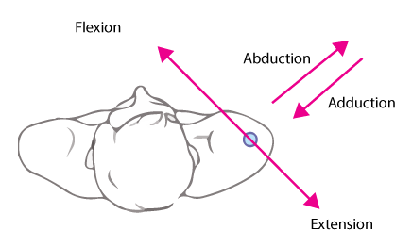

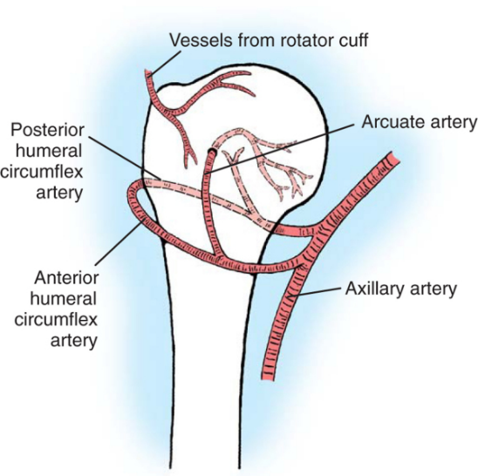
Blood supply of proximal humerus

Arcuate artery of anterior circumflex humeral artery
Posterior circumflex humeral artery
Muscular arteries from rotator cuff muscles

Applied aspects:
- Shoulder joint is more vulnerable for dislocation than any other joint in the body
  - Anterior dislocation is more common than posterior dislocation
  - Fall on the outstretched hand with shoulder abducted and externally rotated dislocates shoulder anteriorly.
- Recurrent anterior shoulder dislocation – abnormal anatomical factors responsible
  - Hill-Sach’s lesion – posterolateral lesion in head of humerus
  - Bankart’s lesion – anterior part of glenoid labrum
  - Erosion of anterior rim of glenoid cavity

Frozen shoulder
Definition – painful restriction of both active and passive shoulder movements due to causes within the shoulder joint or remote
Causes of frozen shoulder are tendinitis of rotator cuff, bicipital tendinitis, fractures and dislocations around shoulder.
Rotator cuff lesions – are usually associated with supraspinatus tendon.

